Male Survivors of Urban Violence and Trauma
Jessica Reichert, Senior Research Analyst

Illinois criminal justice information authority
Research and Analysis Unit
December 15, 2015

A qualitative analysis of jail detainees
Urban violence is a major public health concern and at epidemic levels in some neighborhoods, directly impacting the mental health of its residents. The rate of posttraumatic stress disorder (PTSD) among urban populations is estimated to be around 31 percent, higher than the PTSD
rate among returning Iraq war veterans of 17 percent. The figure depicts different populations that were PTSD-symptomatic (current rather than lifetime prevalence).

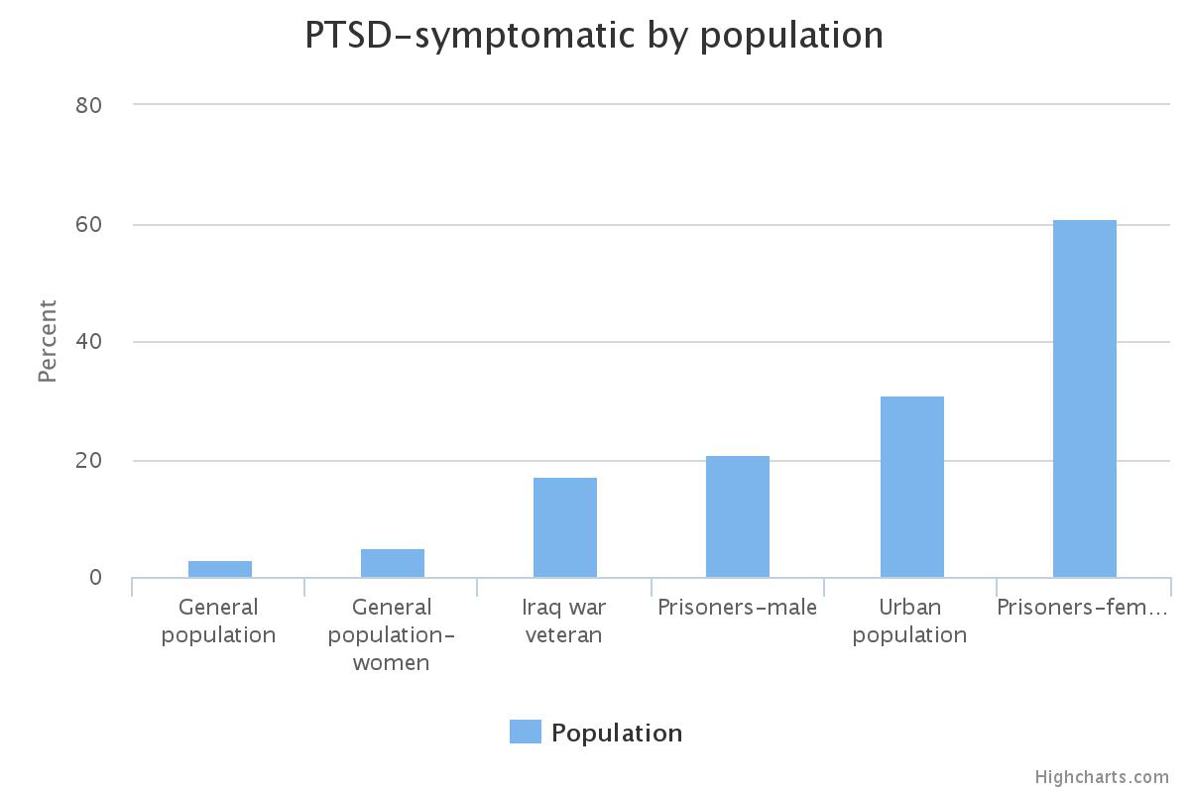
Research has found traumatic events in urban neighborhoods can be associated with later criminal activity and substance use. An estimated 6.3 million people in the United States are in need of PTSD treatment, with higher proportions of sufferers concentrated in urban cities. The cost of gun violence is estimated at $174 billion including loss of work productivity, medical care, pain and suffering, insurance, and criminal justice expenses.
Researchers from the Illinois Criminal Justice Information Authority (Authority) and WestCare Foundation Illinois documented self-reported characteristics, experiences, and backgrounds of male survivors of urban violence. Researchers conducted in-depth interviews with six men receiving substance abuse treatment while in custody at Cook County jail. All showed symptoms of mental health issues, trauma histories, and/or PTSD. The interviews focused on the men’s life stories, traumas they experienced, and their coping mechanisms. Some may assume these men were street savvy, immune to the continuous violence around them and to blame for their circumstances, but the research revealed the men were profoundly negatively affected by their experiences in their homes and neighborhoods.
Key findings

All men said their neighborhoods were dangerous growing up and that crime and gunfire were common. All had been shot at and physically assaulted. Most had been robbed at gunpoint and stabbed. Most had witnessed someone’s murder or someone being seriously injured. Three experienced the sudden loss of a family member who was murdered; all thought at least once they would be killed or seriously injured.

Trauma occurred early. By the age of five, half of those interviewed had already experienced a traumatic event. Domestic disruption and violence was common—three saw their fathers physically abuse their mothers as children and all were either separated from, or abandoned by, a parent. Half of the interviewees were sexually abused or experienced unwanted sexual contact. Half had periods of homelessness. Two interviewees had been diagnosed with a mental illness, one had attempted suicide, and one had serious physical health issues.

Their reactions to traumatic experiences varied. All said they used alcohol or drugs as a way to cope. Five began using drugs and/or alcohol during early adolescence. Four reported nightmares and decreased intimacy or trust in others. Three suffered physical responses to stressful events, including anxiety, cold sweats, and difficulty concentrating. Two noticed impaired relationships with family or friends.

Implications for policy and practice

Further understanding and treatment are necessary to help individuals heal from trauma and improve public health and criminal justice outcomes. Several implications for policy and practice were identified during the course of this research.

Offer treatment to male trauma survivors
None of the interviewees received professional help or employed positive coping skills to address the trauma they had experienced. Screening for trauma and PTSD is needed to uncover issues and develop a treatment plan. Service providers and criminal justice personnel can use a trauma-informed approach—understanding trauma signs and symptoms to support treatment protocols and limit re-traumatization. Training for screening of trauma, as well as trauma-based treatment is necessary. Best practices for trauma/PTSD treatment include individual or group cognitive behavioral therapy and the treatment of co-occurring disorders when substance abuse is present.

Increase awareness of male survivors of urban trauma
Trauma can affect anyone, but the men growing up in urban neighborhoods are more at-risk for experiencing trauma and developing PTSD than those non-urban areas. Public awareness of the trauma experienced by urban males, particularly among service providers and criminal justice system practitioners, is needed. Urban men who seek medical treatment after a traumatic event are rarely referred to mental health services.

Conduct further research on urban trauma
Research is needed to better understand the prevalence of trauma among different populations and those most at-risk, and identify strategies to help victims of urban violence. Better awareness and understanding of the prevalence of PTSD in urban areas will support development of best practices to identify and treat individuals.

Morris, E. (no date). Youth violence: Implications for Posttraumatic stress disorder in urban youth. Washington, DC: National Urban League Policy Institute.
Donley, S., Habib, L., Jovanovic, T., Kamkwalala, A., Evces, M., Egan, G., Bradley, B., & Ressler, K.J. (2012). Civilian PTSD symptoms and risk for involvement in the criminal justice system. Journal of American Academy of Psychiatry Law, 40, 522–529.; Hoge ,C.W., Terhakopian , A., Castro, C.A., Messer, S.C., & Engel, C.C., (2007). Association of posttraumatic stress disorder with somatic symptoms, health care visits, and absenteeism among Iraq War veterans. The American Journal of Psychiatry, 164 (1), 150-153.
Kessler R.C., Sonnega, A., Bromet, E. , Huges, M., & Nelson, C.B. (1995). Posttraumatic stress disorder in the National Comorbidity Survey. A*rchives of General Psychiatry*, 52(12), 1048–1060. ; Resnick, H.S., Kilpatrick, D.G., Dansky, B.S., Saunders, B.E., & Best, C.L. (1993). Prevalence of civilian trauma and posttraumatic stress disorder in a representative national sample of women, Journal of Consulting and Clinical Psychology, 61(6), 984-991.; Hoge ,C.W., Terhakopian , A., Castro, C.A., Messer, S.C., & Engel, C.C., (2007). Association of posttraumatic stress disorder with somatic symptoms, health care visits, and absenteeism among Iraq War veterans. The American Journal of Psychiatry, 164(1), 150-153; GGibson, L.E., Holt, J.C., Fondacaro, K.M., Tang, T.S., Powell, T.A., & Turbitt, E.L. (1999). An examination of antecedent traumas and psychiatric comorbidity among male inmates with PTSD. Journal of Traumatic Stress, 12(3), 473-484.; Donley, S., Habib, L., Jovanovic, T., Kamkwalala, A., Evces, M., Egan, G., Bradley, B., & Ressler, K.J. (2012). Civilian PTSD symptoms and risk for involvement in the criminal justice system. Journal of American Academy of Psychiatry Law, 40, 522–529.; Reichert, J. & Bostwick, L. (2010). Post-traumatic stress disorder and victimization among female prisoners in Illinois. Chicago, IL: Illinois Criminal Justice Information Authority..
Breslau, N., Chilcoat, H.D., Kessler, R.C., & Davis, G.C. (1999). Previous exposure to trauma and PTSD effects of subsequent trauma: results from the Detroit Area survey of trauma. American Journal of Psychiatry, 156, 902–907.; Breslau, N., Davis G.C., & Andreski, P. (1995). Risk factors for PTSD-related traumatic events: a prospective analysis. American Journal of Psychiatry, 152, 529–535.; Scott, C. L. (Ed.) (2010). Handbook of correctional mental health (2nd ed.). Washington: American Psychiatric Publishing.; Widom, C. S., & Maxfield, M. G. (2001). An update on the “cycle of violence. Washington, DC: National Institute of Justice.
Norris, F. H., & Slone L.B. (2013). Understanding research on the epidemiology of trauma and PTSD. PTSD Research Quarterly, 24(2-3), 1-5.
Miller, T. R. (2012). The cost of firearm violence. Calverton, MD: Pacific Institute for Research and Evaluation.
Substance Abuse and Mental Health Services Administration. (2015). Trauma-informed approach and trauma-specific interventions. Rockville, MD: author. Retrieved from http://www.samhsa.gov/nctic/trauma-interventions.
Adams, E.J. (2010). Healing invisible wounds: Why investing in trauma-informed care for children makes sense. Washington, DC: Justice Policy Institute.
Beck, G.J., & Coffey, S.F., (2005). Group cognitive behavioral treatment for PTSD: Treatment of motor vehicle accident survivors. Cognitive Behavioral Practice, 2(3): 267–277.
Reese, C., Pederson, T., Avila, S., Joseph, K., Nagy, K., Dennis, A., Wiley, D., Starr, F., & Bokhari, F. (2012). Screening for traumatic stress among survivors of urban trauma. Journal of Trauma Acute Care Surgery, 73(2), 462-468.
Rich, J.A., & Grey, C.M. (2005). Pathways to recurrent trauma among young black men: Traumatic stress, substance use, and the “code of the street.” American Journal of Public Health, 95(5), 816–824.
Rich, J.A., & Grey, C.M. (2005). Pathways to recurrent trauma among young black men: Traumatic stress, substance use, and the “code of the street.” American Journal of Public Health, 95(5), 816–824.
Ouimette, P., Read, J.P., Wade, M., & Tirone, V. (2010). Modeling associations between posttraumatic stress symptoms and substance use. Addictive Behaviors, 35, 64–67.

